**ATM MACHINE**

Project submitted to the

SRM University – AP, Andhra Pradesh

for the partial fulfillment of the requirements to award the degree of

**Bachelor of Technology**

In

**Computer Science and Engineering**

**School of Engineering and Sciences**

Submitted by:

**SANJANA LAKKIMSETTY(AP21110010685**)

**YASWANTH SRI RAM JAYYAVARAPU(AP21110010686)**

**PRASANNA KUMAR JETTI(AP21110010687)**

**CHAKRADHAR PUTTI(AP21110011223)**

Under the Guidance of

**Mohammad Miskeen Ali**

**SRM University–AP**

**Neerukonda, Mangalagiri, Guntur**

**Andhra Pradesh – 522 240**

**[December,2022]**

# Certificate 1

Date: 19-Dec-22

This is to certify that the work present in this Project entitled “**ATM MACHINE**” has been carried out by **SANJANA LAKKIMSETTY** under my/our supervision. The work is genuine, original, and suitable for submission to the SRM University – AP for the award of Bachelor of Technology/Master of Technology in **School of Engineering and Sciences**.

**Supervisor**

(Signature)

**Mohammad Miskeen Al**

**Head of the Dept.**

(Signature)

**JATINDRA KUMAR DASH**

**Certificate 2**

Date: 19-Dec-22

This is to certify that the work present in this Project entitled “**ATM MACHINE**” has been carried out by **YASWANTH SRI RAM JAYYAVARAPU** under my/our supervision. The work is genuine, original, and suitable for submission to the SRM University – AP for the award of Bachelor of Technology/Master of Technology in **School of Engineering and Sciences**.

**Supervisor**

(Signature)

**Mohammad Miskeen Al**

**Head of the Dept.**

(Signature)

**JATINDRA KUMAR DASH**

# Certificate 3

Date: 19-Dec-22

This is to certify that the work present in this Project entitled “**ATM MACHINE**” has been carried out by **PRASANNA KUMAR JETTI** under my/our supervision. The work is genuine, original, and suitable for submission to the SRM University – AP for the award of Bachelor of Technology/Master of Technology in **School of Engineering and Sciences**.

**Supervisor**

(Signature)

**Mohammad Miskeen Al**

**Head of the Dept.**

(Signature)

**JATINDRA KUMAR DASH**

# Certificate 4

Date: 19-Dec-22

This is to certify that the work present in this Project entitled “**ATM MACHINE**” has been carried out by **CHAKRADHAR PUTTI** under my/our supervision. The work is genuine, original, and suitable for submission to the SRM University – AP for the award of Bachelor of Technology/Master of Technology in **School of Engineering and Sciences**.

**Supervisor**

(Signature)

**Mohammad Miskeen Al**

**Head of the Dept.**

(Signature)

**JATINDRA KUMAR DASH**

# Acknowledgements:

I would like to express our special thanks to our mentor

**Mr. Mohammad Miskeen Ali** for his time and efforts provided throughout the academic year. Your useful advice and suggestions were really helpful to us during the project completion.

We have taken a lot of effort into this project. However completing this project would not have been possible without the support and guidance of a lot of individuals who had participated in the group project.

**SANJANA LAKKIMSETTY(AP21110010685**)

**YASWANTH SRI RAM JAYYAVARAPU(AP21110010686)**

**PRASANNA KUMAR JETTI(AP21110010687)**

**CHAKRADHAR PUTTI(AP21110011223)**

# LIST OF TABLES:

1.Abstract

2.Introduction

3.Problem definition

4.Requirements

5.Methodology

6.Data Flow Diagram

7.Source Code

8.Output

9.Discussion

10.Conclusion

# Abstract:

The proposed Python project is an engineering approach to enhance current banking activities. The software works as a controller of the ATM machine during transaction of money. The implementation of project is beneficial to both the banks and the costumers.

The development of technology has carried drastic change in all sectors and one of them is bank. The present money transaction process completely differs from the older traditional method using checks and tokens. Nowadays, people prefer different cards such as VISA, MASTER CARD, etc. to withdraw money from bank. This is possible only though Automatic Teller Machine with a properly installed software.

The use of a software in ATM machine creates ease and a comfort in money transaction. One can withdraw money at any place provided with an ATM centre. It reduces the risk of losing money, and being stolen and cheated. The use of software helps in safe, reliable and secured banking.

After the implementation of project in bank, the numbers of daily costumers visiting the bank for withdrawing money is effectively reduced. As a result of this, the working load in the bank is obviously reduced and the numbers of account staffs in bank office can be decreased. Thus, the project carries an economical balance in

# Introduction

Automated Teller Machine enables the clients of a bank to have access to their account without going to the bank. This is achieved only by development the application using online concepts.

When the product is implemented, the user who uses this product will be able to see all the information and services provided by the ATM, when he enters the necessary option and arguments. The product also provides services like request to withdraw the cash, deposit cash and other advanced requirement of the user. The data is stored in the database and is retrieved whenever necessary. The implementation needs ATM machine hardware to operate or similar simulated conditions can also be used to successfully use the developed product.

**PROBLEM DEFINITION:**

The project entitled ATM system has a drastic change to that of the older version of banking system, customer feel inconvenient with the transaction method as it was in the hands of the bank employees. In our ATM system, the above problem is overcome here, the transactions are done in person by the customer thus makes the customers feel safe and secure. Thus the application of our system helps the customer in checking the balance and transaction of the amount by validating the pin number therefore ATM system is more user friendly.

**REQUIREMENTS:**

* + 1. **SOFTWARE REQUIREMENTS**:

|  |  |
| --- | --- |
| **COMPONENT** | **REQUIREMENT** |
| Operating system | Windows 10 or above |
| Language used | Python Language |
| Compilers | Visual Studio Code |

* + 1. **HARDWARE REQUIREMENTS:**

|  |  |
| --- | --- |
| **COMPONENT** | **REQUIREMENT** |
| Processor | 10th Gen intel core i5 and above |
| RAM | Minimum 256 mb |
| HDD | 1. B |

**Methodology:**

The project entitled ATM system has a drastic change to that of the older version of banking system, customer feel inconvenient with the transaction method as it was in the hands of the bank employees. In our ATM system, the above problem is overcome here, the transactions are done in person by the customer thus makes the customers feel safe and secure. Thus the application of our system helps the customer in checking the balance and transaction of the amount by validating the pin number therefore ATM system is more user friendly.

In this way our Project was done:

|  |  |
| --- | --- |
| **Module Name** | **Uses** |
| Time | To be Realistic |

# Data Flow Diagram:

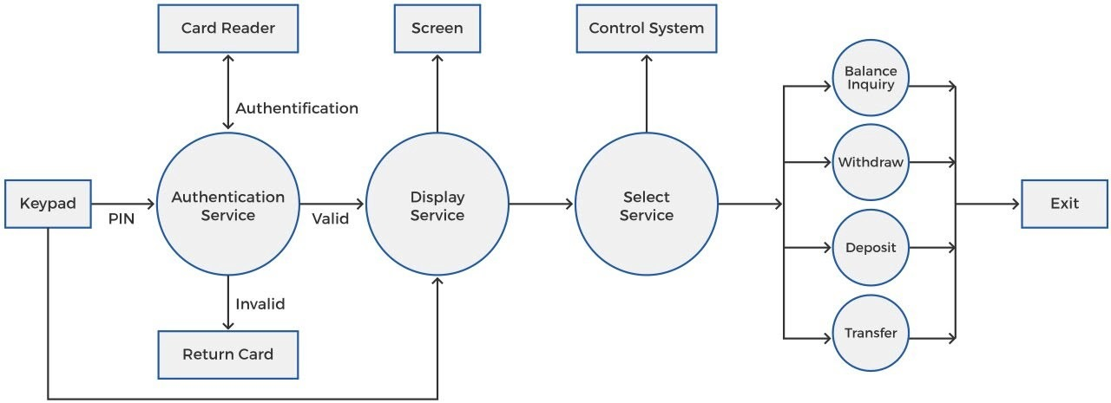

SOURCE CODE:

import time as t

user_pin = 1234

user_balance = 100000

user_name = "MR.Ali"

print("Welcome to your bank account", user_name, end = "\n\n")

choice = 10

while (True):

print("\t\t0. Logout and Exit")

print("\t\t1. View Account Balance")

print("\t\t2. Withdraw Cash")

print("\t\t3. Deposit Cash")

print("\t\t4. Change PIN")

print("\t\t5. Return Card")

choice = int(input("Enter number to proceed > "))

print("\n\n")

if choice == 0:

print("Exiting...")

t.sleep(2)

print("You have been logged out. Thank you!\n\n")

break

elif choice in (1,2,3,4,5):

num_of_tries = 3

while (num_of_tries!=0):

input_pin = int(input("Please enter your 4-digit PIN > "))

if input_pin == user_pin:

print("Account autorized!\n\n")

if choice == 1:

print("Loading Account Balance...")

t.sleep(1.5)

print("Your current balance is Rs.", user_balance, end = "\n\n\n")

break

elif choice == 2:

print("Opening Cash Withdrawal...")

t.sleep(1.5)

while(True):

withdraw_amt = float(input("Enter the amount you wish to withdraw >"))

if withdraw_amt>user_balance:

print("Can't withdraw Rs.", withdraw_amt)

print("Please enter a lower amount!")

continue

else:

print("Withdrawing Rs.", withdraw_amt)

confirm = input("Confirm? Y/N > ")

if confirm in ('Y', 'y'):

user_balance-=withdraw_amt

print("Amount withdrawn - Rs.", withdraw_amt)

print("Remaining balance - Rs.", user_balance, end = "\n\n\n")

break

else:

print("Cancelling transaction...")

t.sleep(1)

print("Transaction Cancelled!\n\n")

break

break

elif choice == 3:

print("Loading Cash Deposit...")

t.sleep(1.5)

deposit_amt = float(input("Enter the amount you wish to deposit > "))

print("Depositing Rs.", deposit_amt)

confirm = input("Confirm? Y/N > ")

if confirm in ('Y', 'y'):

user_balance+=deposit_amt

print("Amount deposited - Rs.", deposit_amt)

print("Updated balance - Rs.", user_balance, end = "\n\n\n")

else:

print("Cancelling transaction...")

t.sleep(1)

print("Transaction Cancelled!\n\n")

break

elif choice == 4:

print("Loading PIN Change...")

t.sleep(1.5)

pin_new = int(input("Enter your new PIN > "))

print("Changing PIN to", pin_new)

confirm = input("Confirm? Y/N > ")

if confirm in ('Y', 'y'):

user_pin = pin_new

print("PIN changed successfully! \n\n")

else:

print("Cancelling PIN change...")

t.sleep(1)

print("Process Cancelled!\n\n")

break

else:

print("Loading Card Return...")

t.sleep(1.5)

print("Returning your ATM Card")

confirm = input("Confirm? Y/N > ")

if confirm in ('Y', 'y'):

print("Card returned successfully! \n\n")

else:

print("Cancelling process...")

t.sleep(1)

print("Process Cancelled!\n\n")

break

else:

num_of_tries-=1

print("PIN incorrect! Number of tries left -", num_of_tries, end = "\n\n")

else:

print("Exiting...")

t.sleep(2)

print("You have been logged out. Thank you!\n\n")

break

else:

print("Invalid input!")

print("\t\t0. Enter 0 to Logout and Exit!")

        continue

OUTPUT SCREENSHOTS:

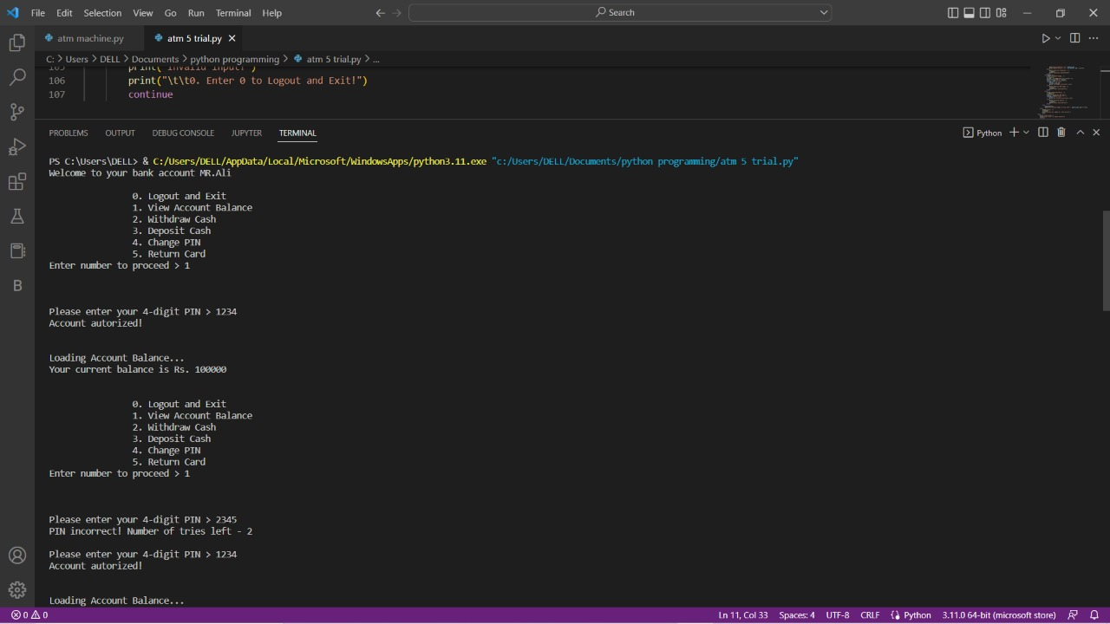

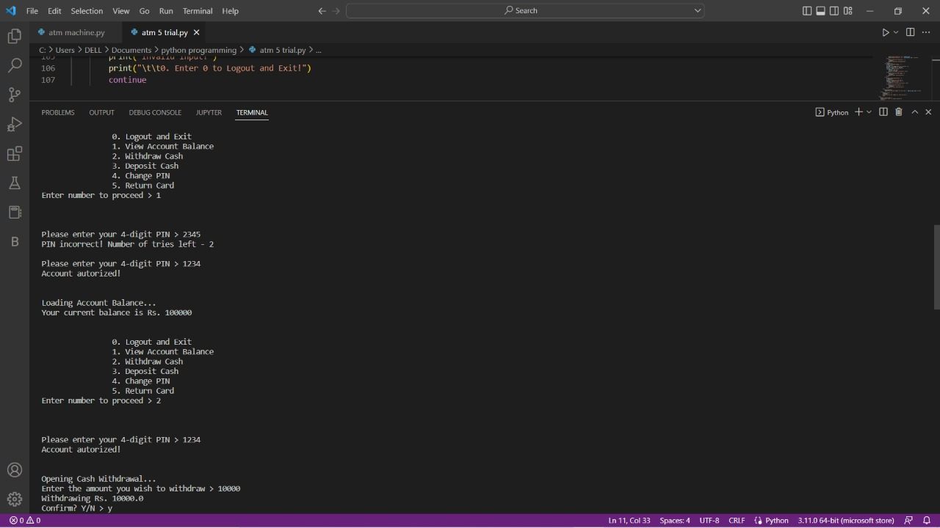

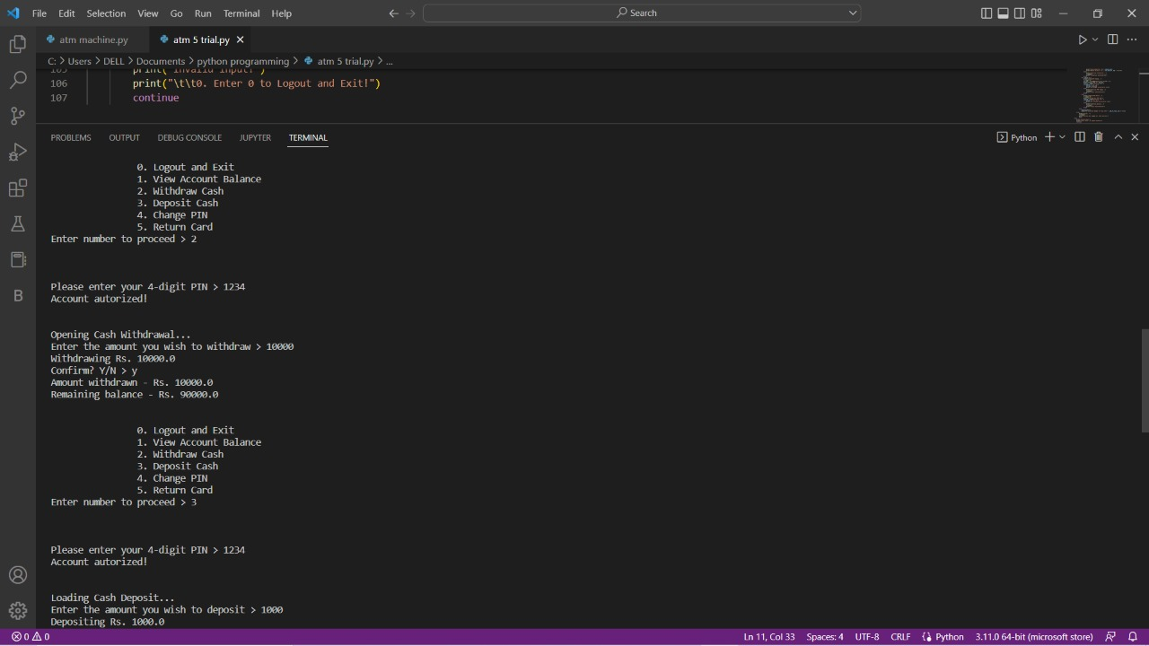

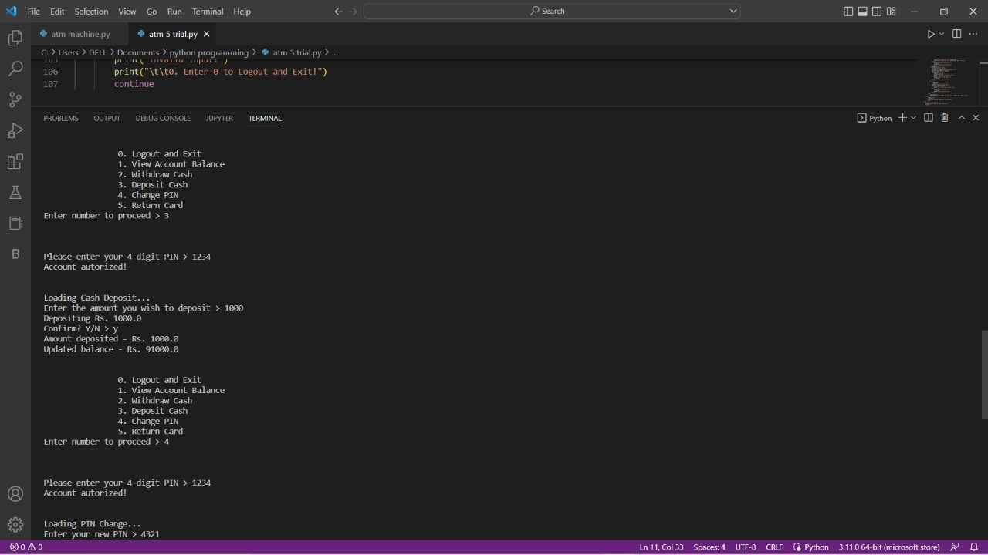

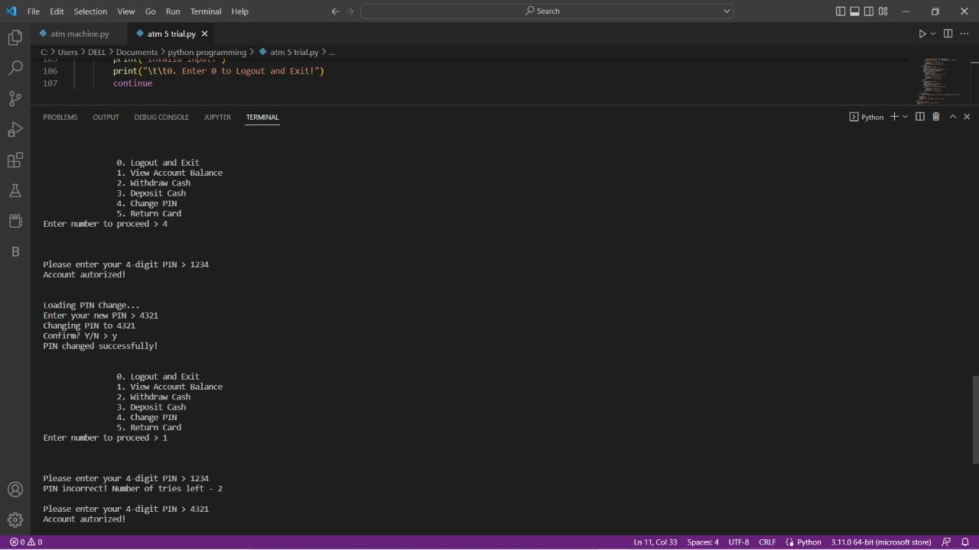

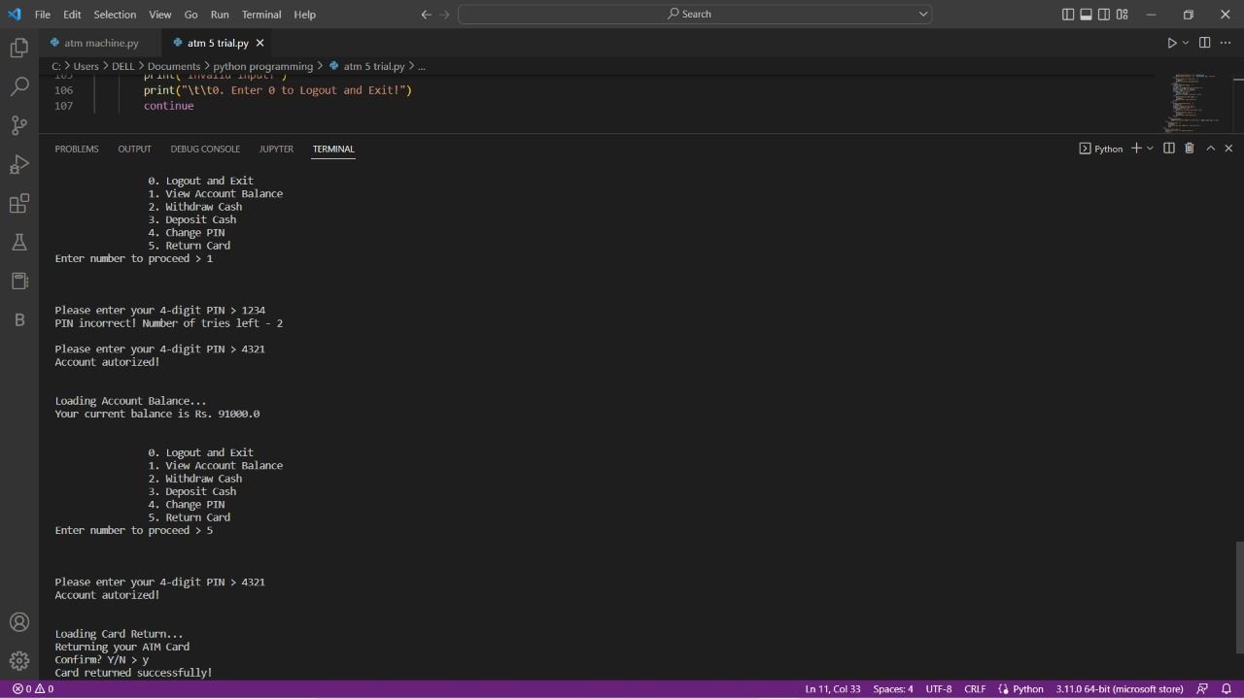

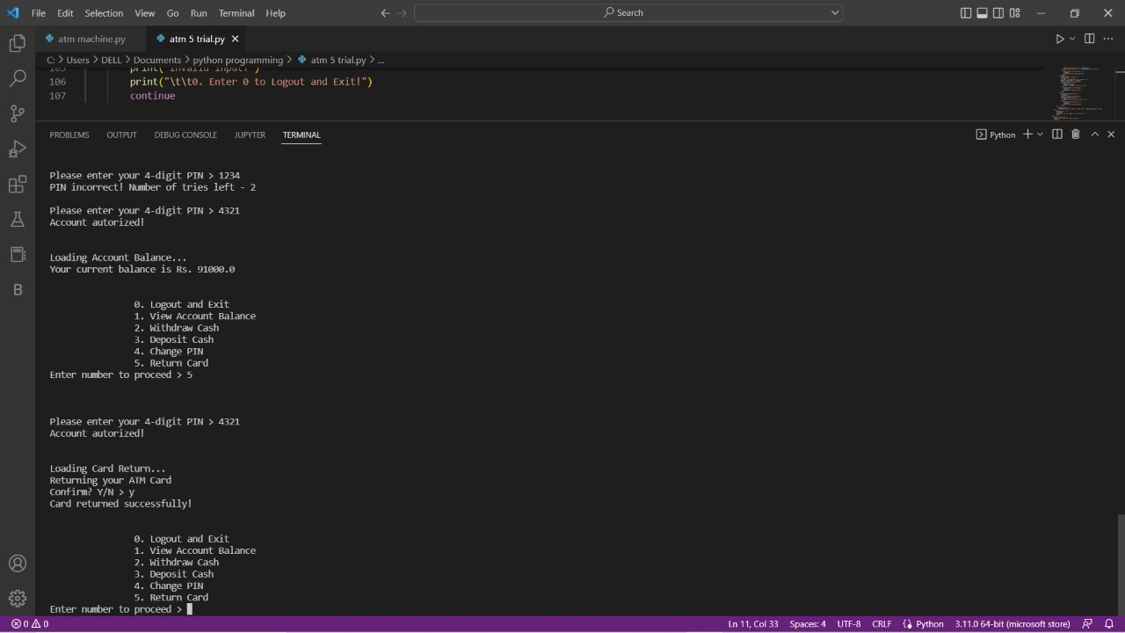

**DISCUSSION:**

This is the ATM simulation for a single user,

MR. Ali is the person who has already successfully logged into his account on

the ATM Machine.

User is given six options to choose,

0.Logout and Exit

1.view account balance

2.withdraw cash

3.deposit cash

4.change pin

5.return card

By pressing 0, simply log us out of the ATM

By pressing 1, it takes us to the "View Account Balance" option,

where, after we’ve entered the correct PIN for our bank account,

we are able to see how much money is in our bank account

By choosing 2, will load up the cash withdrawal screen,

wherein after we have entered the right PIN for our bank account, we will be able to enter an amount to withdraw from our account.

On entering 3, we are taken to the cash deposit option of the ATM,

where we’ll be able to deposit an amount into our bank account.

Pressing 4 allows me to change my ATM PIN.

The last option, 5, is for returning the ATM card

**CONCLUSION:**

From this presentation, one can observe that an ATM system is associated with the bank transactions of the consumers.

Majorly, the ATM system is utilized for the money associated transactions from the consumers.

Consumers make major use of ATM to withdraw money from their bank account.

It is a fast way to get money out of your account, especially when on the go or during a trip.